Map of the Central Region
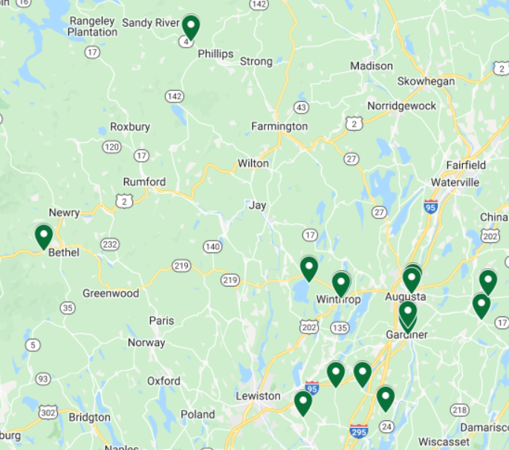
1. Fine Mess Pottery  131 Cony St Augusta | 9. Margaret Melanson  287 Water St, Gardiner
2. Red Door Pottery  14 North Pearl St, Augusta | 10. Loken Pottery  26 Bowman St, Farmingdale
3. A Lakeside Studio Pottery  12 Cedar Point Rd, Wayne | 11. Whitefield Pottery  442 Howe Rd, Whitefield
4. d. harwood Pottery  196D Main St, Winthrop | 12. Maple Lane Pottery  36 Greeley Rd, Windsor
5. The Art Walk Shop & Studio  121 Main St, Winthrop | 13. Bog Pond Pottery  Bog Pond Road, Phillips
6. Pots in Bowdoin  1192 Litchfield Rd, Bowdoin | 14. Martha Grover & Josh Rysted  630 W Bethel Rd, Bethel
7. Delilah Pottery  468 Carding Machine Rd, Bowdoinham | 15. Fischer Pottery  394 Ridge Rd, Lisbon Falls
8. Jeffrey Lipton Pottery
1508 Richmond Rd, Litchfield
Saturday, 10-5
Sunday, 11-4
The Maine Pottery Tour is a self-guided driving tour of pottery & ceramics studios around the state.
On April 30th & May 1st, you have an opportunity to meet the artists, peek in the kilns, watch demos, & see the spaces where the magic happens. The Maine Pottery Tour celebrates its 9th year with 54 studios!
In the Central Region, we have 15 participating studios. For a complete list, please visit www.mainepotterytour.org . There you will find links to studios and an interactive map to plan your pottery road trip.

The Maine Pottery Tour is funded in part by a grant from the Maine Arts Commission, an independent state agency supported by the National Endowment for the Arts.

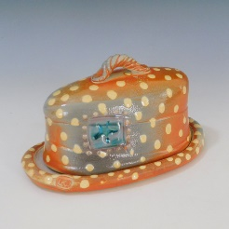
Fine Mess Pottery
131 Cony St
Augusta
With guest artist Liz Downs
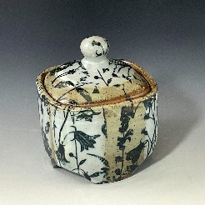
Red Door Pottery
14 N. Pearl St Augusta

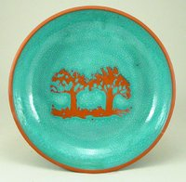
A Lakeside Studio Pottery
12 Cedar Point Rd
Wayne

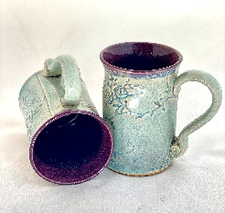
d harwood Pottery
196D Main St Winthrop

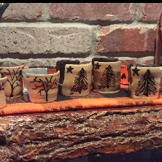
The Art Walk Shop & Studio
121 Main St Winthrop

Pots in Bowdoin
1192 Litchfield Rd
Bowdoin
One stop, 3 potters!

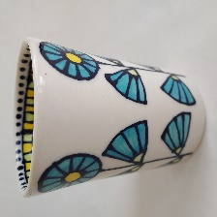
Delilah Pottery
468 Carding Machine Rd
Bowdoinham
With guest artist Dominique Ostuni

Jeffrey Lipton Pottery
1508 Richmond Road
Litchfield

Maple Lane Pottery
36 Greeley Rd, Windsor
With guest artist Alex Portela
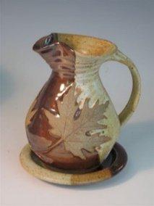

Loken Pottery
26 Bowman St, Farmingdale

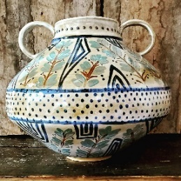
Margaret Melanson
287 Water St
Gardiner

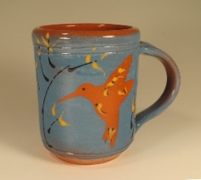
Whitefield Pottery
442 Howe Rd, Whitefield

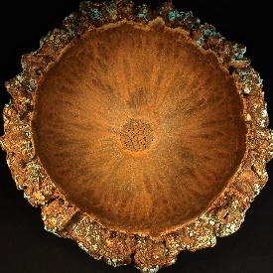
Bog Pond Pottery
63 Bog Pond Rd
Phillips

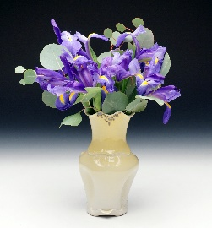

Martha Grover & Josh Rysted
630 West Bethel Rd Bethel

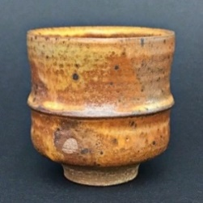
Tim Fischer Pottery
394 Ridge Rd Lisbon

Many Thanks to our sponsors!
Monkitree, Gardiner
Maine Potters Market, Portland
Portland Pottery, Portland
Bay View Company, Saco
Full Circle Artisans Gallery, Cornish
Maine Local Market, Hallowell
Hallowell Clayworks, Hallowell
Maine Crafts Association, Gardiner
Maine Arts Commission

